ANNOTATION

In a diploma project there was developed a corporate system for document management, users, projects with collaboration ability. Provided main aspects that influence on creation of software. Developed server and user part of portal.

KEY WORDS: corporate portal, collaboration, documentation, Java EE, Spring Framework.
CONTENT
INTRODUCTION 5
1 MARKET ANALYSIS AND SOLUTIONS 7
1.1 Advantages and disadvantages of current solutions 7
1.2 Licensing and open API 7
1.3 Development technology 9
1.4 Technical review of the product 9
1.5 Historical overview of the corporate sector 10
1.6 Portlets 11
1.7 Content management system 11
1.8 Document management system 11
2 ALGORITHMIC OF CREATION OF CORPORATE SYSTEMS 12
2.1 Model of system architecture 12
2.2 Designing a database 13
2.3 InnoDB mechanism 14
2.4 Relations in tables 14
2.5 Database architecture 14
2.6 The external layout of the site 15
2.7 Project structure 16
2.8 Sequence diagram 17
2.9 Authorization and Authentication 17
2.10 Algorithm of user authorization 18
3 SOFTWARE IMPLEMENTATION SYSTEMS TO MANAGE USERS, DOCUMENTS AND TASKS 19
3.1 The implementation of the database 19
3.2 Implementation of a Web interface 19
3.3 The navigation panel 19
3.4 Main menu 20
3.5 Working with data 20
3.6 Categories of portal 20
4 ECONOMIC EFFICIENCY OF SOFTWARE USAGE 24
4.1 Economic efficiency of software development and implementation 24
4.2 Building a network graph 24
4.3 Construction of the network graph 25
5 SAFETY WORK 26
5.1 Analysis of potential hazards and hazardous working conditions 26
5.2 Maintenance of normal working conditions 27
5.3 Ensuring safety when working with computers 27
5.4 Fire safety and safety in emergency situations 28
CONCLUSION 30
LIST OF SOURCES 31
INTRODUCTION

A major economic point of contact for any commercial organization is availability some factors, which recognize clear company position on market.
There are a lot of factors that belong to that variants, in particular:
1. the capital of enterprise;
2. material resources;
3. technical base;
4. qualified personnel;
5. place on the domestic and foreign markets;
6. availability of modern means of production and business;
7. and others.
That's why, each part of doing business should be considered in all details and embedded in life. But if you look in terms of development, high-quality software plays a certain most important role at this stage of civilization.
Nowadays it's not possible to keep all data in paper form, is not possible to send printed messages or communicate only by phone and get news only at the meetings.
In our rapid development time, news change with colossal speed, so it's not possible to be always in touch without some software product.
Imagine informant which informs You any news or any useful information in Your own time and can filter and analyze data from previous requests.
Also at this moment it's difficult to imagine inability to collaborate on documents and on spreadsheets.
These technologies have been used by people and businesses for a long time already, starting from the smallest employing of two people to the huge number of employees over a hundred thousand.
But it just uses a lot of technologies that are difficult to set up and require extensive maintenance costs.
Therefore, there have been developed a lot of services and applications that facilitate business in network;
This software is used in all directions of life, started from schools and hospitals and ending with large corporations that build spaceships.
That's why it's not possible to develop a universal product which can ensure all requirements.
Each area has its own nuances.
An interesting area for research was the corporate software for small and medium businesses.
Currently, there are many software products for commercial purposes, but they are mostly designed for large corporations and enterprises.
That's why using them for smaller firms is not applicable or is very difficult on financial side (support costs precede benefits).

1 MARKET ANALYSIS AND SOLUTIONS

Currently, there are many ready-made solutions of corporate portals.
They can provide businesses with all necessary features and add-ons, beginning from the accounting system of employees, and completing the analytics system and data collection, that all depends on market needs and a company.
However, almost of them are designed mostly for large companies, and small companies should spend a lot of money for purchase licenses or not to enjoy the full benefits of the corporate portal.
Therefore, there was done an overview of products and highlighted the main advantages and disadvantages, also showed the current used by license of distribution software.

1.1 Advantages and disadvantages of current solutions

After analysis of current area, we can can identify several key issues that will be used to develop further software.
Some part of the software corporate portals are developed by standards.
All applications can easily interact with each other.
However they have a great lack for small business, their code is closed and they have huge cost of licenses.
Therefore, small companies (up to 100 people) simply are unable to afford such luxury.

1.2 Licensing and open API

It was the analysis of current products and their licenses, and found that almost 90% using proprietary solutions.
After some analysis, it seems, had to give small businesses the opportunity to use the product on the basis of free distribution of code, they would be better tried, and eventually invested his money, or simply buy support.
That is, use one of the open licenses such as GNU Public License.
The economic benefit of the product will be based on paid support, starting from servers selection - to set up it and product support.
But developers can add to the overall repository their changes and fix errors that speed up the development process.
The main development strategy is focused on rapid market research and looking for new potential customers.
Also, much attention will be attend to the market of post Soviet republics, as currently fast grown business market, that demand is, and the proposal does not fully meet the needs.
Portals that are developed now almost all are aimed to European and American market, and Asia also.
So based on this, basic requirements have been allocated, as our legislation (for example, job placement workers, documentation, conversion rates, etc.) and localization services.
Moreover, user support will be much easier and more efficient at native country than from abroad, which will give us an advantage over other existing products.
Also big attention will be given to open API for connection with existing applications.
Most of all, existing solutions are mainly based on the closed protocol and that make users to become attached to their systems and depend on them.
Interface and the system of modern products are very heavy and multi-functional, which requires a lot of resources both sides: in user and in server.
This aspect will be also simplified and it make product known on current market.

1.3 Development technology

Based on current standards and use of basic technologies it was decided to develop application based on Java.
After all, Sun (now Oracle) provide main point on market of standardization for portlets, so that will be easy to adapt to current decisions.
Of course it will be used all advantages of Java EE.
For flexible and rapid development will be applied Spring Framework with Hibernate ORM wrapper on the top of the database MySQL.
For the frontend UI logic is mainly used jQuery framework.
Search will be provided by Apache Lucene.
Backend server will run on Apache Tomcat.
At current moment there is no plans for standardization of portlets, just maybe in the future will be highlighted this point to implement in the system.

1.4 Technical review of the product

Consider in more details availability of modern business solutions.
Every company always faced the problem of accounting staff, accounting finance, document collaboration and others.
There is a huge and essential need for the sharing of documents, corporate calendar, corporate blog, spreadsheets and information boards.
Enterprise Portal (also known as enterprise information portal (EIP) or corporate portal) is the basis for integrating information, people and processes within an organization.
This enables you to provide a single point of access, often as a web-interface which use for personalization of information with using specific software applications. One beig benefit of corporate portals is decentralized content making and management that is stored on a remote server and constantly updated.

1.5 Historical overview of the corporate sector

The mid-1990s saw the advent of public Web portals like AltaVista, AOL, Excite, and Yahoo!. These sites provided a key set of features (e.g., news, e-mail, weather, stock quotes, and search) that were often presented in self-contained boxes or portlets. Before long, enterprises of all sizes began to see a need for a similar starting place for their variety of internal repositories and applications, many of which were migrating to Web-based technologies.
By the late 1990s, software vendors began to produce prepackaged enterprise portals. These software packages would be toolkits for enterprises to quickly develop and deploy their own customized enterprise portal. The first commercial portal software vendor began to appear in 1998. Pioneers in this marketing included "pure play" vendors like Epicentric, Plumtree Software and Viador. The space, however, quickly became crowded by 2002, with the entry into the market of competing product offerings from application server vendors (such as BEA, IBM, Passageways, Oracle Corporation and Sun Microsystems), who saw portals as an opportunity to stave off the commoditization of application server technology, and Business Intelligence vendors such as Liferay portal. Enterprises may choose to develop multiple enterprise portals based on business structure and strategic focus while reusing architectural frameworks, component libraries, or standardized project methods (e.g. B2E, B2C, B2B, B2G, etc.).
In 2003, vendors of Java-based enterprise portals produced a standard known as JSR-168. It was to specify an API for interoperability between enterprise portals and portlets. Software vendors began producing JSR-168 compliant portlets that can be deployed onto any JSR-168 compliant enterprise portal. The second iteration of the standard, JSR-286, is final-released on 12 Jun, 2008.

1.6 Portlets

Portlets are pluggable user interface software components that are managed and displayed in a web portal. Portlets produce fragments of markup code that are aggregated into a portal. Typically, following the desktop metaphor, a portal page is displayed as a collection of non-overlapping portlet windows, where each portlet window displays a portlet. Hence a portlet (or collection of portlets) resembles a web-based application that is hosted in a portal. Some examples of portlet applications are email, weather reports, discussion forums, and news.
Portlet standards are intended to enable software developers to create portlets that can be plugged in to any portal supporting the standards.

1.7 Content management system

A content management system (CMS) is a computer system that allows publishing, editing, and modifying content as well as site maintenance from a central page. It provides a collection of procedures used to manage workflow in a collaborative environment. These procedures can be manual or computer-based.

1.8 Document management system

A document management system (DMS) is a computer system (or set of computer programs) used to track and store electronic documents and/or images of paper documents. It is usually also capable of keeping track of the different versions modified by different users (history tracking). The term has some overlap with the concepts of content management systems. It is often viewed as a component of enterprise content management (ECM) systems and related to digital asset management, document imaging, workflow systems and records management systems.
2 ALGORITHMIC OF CREATION OF CORPORATE SYSTEMS

In the early development of any software much attention should be paid to system design, because it will depend on the ease and accuracy further development of system, its maintenance and improvement.
Therefore, the design provides a main component of the software.
Required items for a successful product launch area:
-building a UML class diagram;
-construction diagram of relations between objects;
-designing the database;
-mock-ups of the future interface;
-clear distinction between system modules and their interactions.
As mentioned above, primarily task is to develop the chart classes, show the relationship between objects and their role in the system and the overall interaction.

2.1 Model of system architecture

All work is organized on the principle of MVC pattern.
Model-view-controller - architectural pattern used in the design and software development.
As shown in Figure 2.1 template divides the system into three parts: model, view and data.
It is used to separate data (model) of the user interface (view), so that changes have minimal impact on work with data, and changes in the data model can be made without change the user interface.
The main objective of this pattern - flexible design software, which should facilitate further changes or extension programs, and enable reuse of individual components of the program.
Also use this template in large systems provides some ordering of their structure and makes them understandable by general reducing complexity.
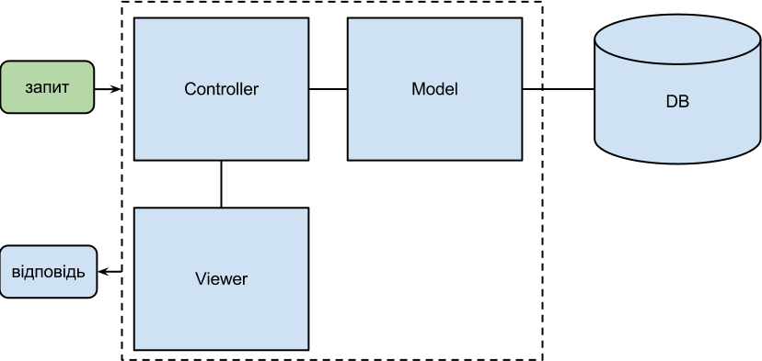
Figure 2.1 – MVC technology

As mentioned earlier, the architectural pattern Model View Controller (MVC) divides the program into three parts. In the triad of responsibilities to the component model (Model) is a data storage and software interface to them. View (View) responsible for the presentation of these data to the user. Controller (Controller) controls the components receiving signals as a response to user actions, and reports changes in the component model. This internal structure divide system into separate parts and allocates responsibilities among the various components.

2.2 Designing a database

The database is based on DBMS MySQL - an open system. The relationship with users is through the Model of system. There are all required data in the DB. User passwords are stored in encrypted form.
A relational database management system (RDBMS) is a database management system (DBMS) that is based on the relational model as introduced by E. F. Codd.

2.3 InnoDB mechanism

InnoDB is a powerful mechanism (engine) for data storage developed by Finnish company Innobase Oy, which was acquired in 2006 by Oracle Corporation.
Distributed under license GNU General Public License. There are all new versions of MySQL, and since version 5.5 for MySQL is default mechanism.
Use InnoDB allows the use of database features such as transactions, foreign keys. It is also compatible with ACID.
There are two ways to store data file or group of files that are common to all databases and tables, or a data file for each table. Other important features of InnoDB: lock on the level of lines, the possibility of data compression, and MVCC.

2.4 Relations in tables

The unit of the database is table which response for data users, because it depends on it most of the tables. For example, a message or task.
For communication between the tables use foreign keys. Foreign key is an attribute (set of attributes) in some respects "R", which corresponds to the primary key of another relation or of the same relation "R".

2.5 Database architecture

As mentioned above almost all based on respect for table "users". The relation should be based on the model of "one-to-many".
As shown in the picture - all tables in the database are connected. Table "users" links to table documents, comments, blogs, calendars, teams, regions, type of work, wiki, tasks and messages.
This allows user to ensure the depends of a particular category.
For example, a user can have multiple documents or comments here and follow the relation of one-to-many.
Also supporting tables as a category of documents, room category and wiki category tasks with their relation to the main table (for example, a category of tasks can include many tasks).

2.6 The external layout of the site

The basis for the user is appearance - UI (user interface) user interface.
User Interface - a set of tools for processing and displaying information, the most adapted to convenience, in graphical user interface implemented multi-mode, change color, size, visibility (transparency, translucency, invisibility) windows, their location, sorting elements of windows, flexible configure both the windows and their separate elements (files, folders, labels, fonts, etc.), availability of multi users options.
End user don't want to know what is doing inside the program - that's why developing a model of the future project, in our case - a mock of web interface.
Mock-up of interface is built in the usual graphic editor. The main goal of this design is the maximum display all the graphics features of the future work site. Future site layout, including the front page shown in Figure 2.2.
The figure 2.2, which shows the layout of the site can clearly see that the navigation menu is located above the site. This menu should always be available to the user, so it will always move, no matter whether user is: the bottom or top, this bar is always available and the follow the user's actions. There should be placed a quick navigation buttons, such as rapid creation of a task or notes.
Navigational bar is available to the left of all. On this panel are placed all project navigation items. Depending on where user is now, it should highlight the current menu item.
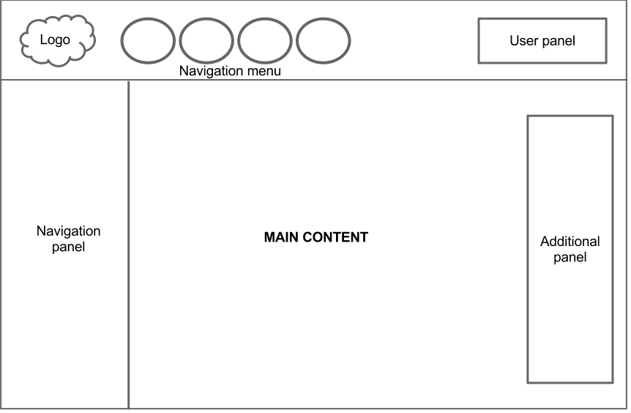
Figure 2.2 – mock-up of web portal

User account is placed right in the navigation bar. It should include all the information to control the current user: exit from site, link to profile, private settings.

2.7 Project structure

After building the database structure and general layout of the site, we should start the development of the server - the site structure. The whole project is based on work of Java EE and on the top of it is Spring framework .

2.8 Sequence diagram

Chart sequence - in UML, a sequence diagram which shows the interaction of objects which are arranged in time. Specifically, these charts represent involved objects and the sequence of messages sent.

Sequence diagram shown as vertical lines of different processes or objects that exist at the same time. Sent messages are displayed as horizontal lines in the order sent.
Defined standard UML 2.0 diagrams sequences have the same opportunities as defined by standard UML 1.x, and have additional re-default order messages.

2.9 Authorization and Authentication

The basis of any corporate system is user management.
That's why should to develop the full range of user interaction. This should include the following important aspects:
-ability to authorize users;
-user roles;
-storing data in encrypted form;
-clear distribution of user rights;
-easy connecting between users;
-ability to integrate with other system services.
Each employee should have uninterrupted access to his account at any time.
Authorization should be implemented understandable for every user and easily accessible.
Office users will be controlled through administrative panel, access to that panel will have only a certain group.

2.10 Algorithm of user authorization

General authorization algorithm is checking the user data and return from the server generated data.
First, server takes sent from the user name and password. Username passed by Acegi Security Controller and encrypt password in code using the algorithm SHA-256. To store data in encrypted form is very dangerous, and if the hacker will get them, he won't have any benefit because data are encrypted and inverse decrypt does not exist. Encryption at the server is through manager authorization and configured in the configuration file with the reference to the Bean with a service which is responsible for the manipulation of user data.

3 SOFTWARE IMPLEMENTATION SYSTEMS TO MANAGE USER, DOCUMENTS, TASKS AND POSSIBILITIES OF WORKING TOGETHER

3.1 The implementation of the database

The overall structure of the database is shown below in previous chapter. The whole code for creating a database implemented by language SQL with using queries to the database.
External links created by using command Reference.
Links to other tables on a web interface implemented using the drop-down menu - it gives the opportunity to provide input data and helps to display existing database records.

3.2 Implementation of a Web interface

User web interface should be easy and intuitive for each member, so it was implemented in light colours and conveniently located with all navigation elements.
All site interface is divided into three main components: main block, navigation bar, the main menu. For easy development of these components used Apache Tiles, which allows You to divide the code into logical units.

3.3 The navigation panel

There are items located on navigation panel for quick access to notes and tasks. You can easily add any tasks with title, tasks and deadline

3.4 Main menu

Web portal browsing is available via the main menu. All available links are located in the main menu:
-home;
-corporate mail;
-tasks;
-calendar;
-notes;
-documents;
-list of workers;
-corporate wiki;
-blog.
When going to any menu, it immediately highlighted - this is done for users convenience to be immediately visible where he is at some moment. It's done via the transfer of the controller attribute to model with named menu.

3.5 Working with data

For data mapping from the form to a database using JPA with Hibernate framework on top of it. For each form in a certain domain (essentially persistence bean). By annotations from the package Javax that bean can transfer Java objects to the database (by using the query language Hibernate Query Language).

3.6 Categories of portal

3.6.1 Authorization
The page of authorization offers users to enter their username and password and in case of invalid data will be displayed error.
In case of entering the correct data, it will record a new session in memory and redirect user to the main page or to the page from which the visitor came.

3.6.2 Corporate mail
All letters received by the user can view in paragraph post. Opposite mail menu displays the number of unread messages (Figure 3.1).
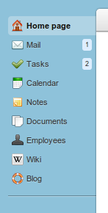
Figure 3.1 – navigation menu

The message subject is shown above each message. The main message text is cut, but when clicking on the message, will be shown full panel with message. Also below message is shown the time of sending message and the sender. When you click on the sender, it redirects You to his personal page. Each unread message is marked with grey colour to make it easier to find. And on clicking, its colour became white and number of messages that are displayed next to menu - will be reduced.
Sending messages is possible from the personal page of each user. After visiting personal page, type message subject and body.

3.6.3 Calendar
Personal calendar allows you to show all notes and tasks. Viewing data in available in three possible views: per month, per week (Figure 3.2) and a per day.
Tasks can be added as for some period or as for whole day. To manipulate entries in the calendar used technology drag & drop from jQuery.

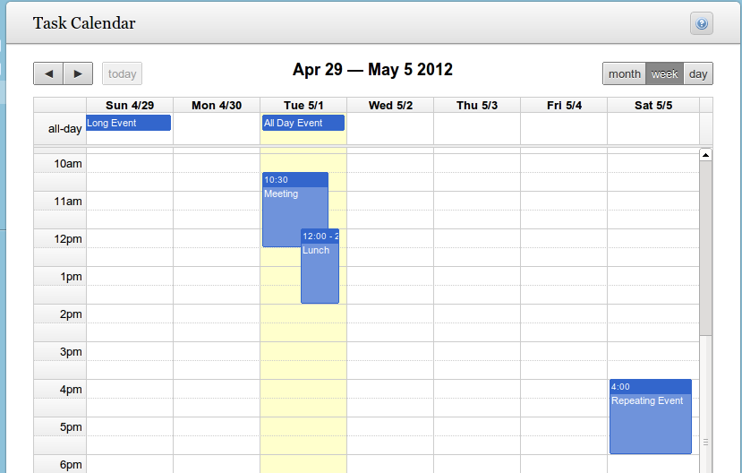
Figure 3.2 – personal calendar.

3.6.4 Tasks and objectives
Category Task is designed to save user's tasks and opportunity to view them in the future. This allows to keep all important tasks in one place.

3.6.5 Users
List of all users is shown in the table with some set of fields. There are some manipulations available with list, such as sorting and pagination.
And if the user has the administrator access - he has ability to create a new user .

3.6.6 Documents
This category is used to store documents for sharing, for example, it may be presentation, documents or other simple notes. To add available three categories: presentation, text documents and spreadsheets. When loading a new document to the portal, you must specify the category of the document and indicate whether the document is for general use or for personal.

3.6.7 Corporate wiki
Corporate wiki mainly designed for sharing useful information among users and has a single central repository of the possibility of any manipulation of documents. Each article has a specific category - making it easier to follow navigation and search.

3.6.8 Corporate blog
Corporate blog has something in common with the wiki, but ability to add information to it can only who has administrative rights and is permission with specific user groups. The main goal of the blog - is likely to inform workers about portal and company news.

4 ECONOMIC EFFICIENCY OF SOFTWARE USAGE

4.1 Economic efficiency of software development and its implementation

In this project need to implement a corporate system for collaborative and simultaneous work of employees for some companies.
There will be implemented messaging system, control objectives and tasks, comfortable corporate calendar, documents collaborate of different types (text documents, presentations, etc.), the system of corporate wiki and blog.
In this work is calculation of economic indicators and analysis of all development work of corporate systems.

4.2 Building a network graph

Network graph is the main planning document in the system network scheduling and management.
For each work should be considered:
-what work should be completed before the start;
-what work can be started after the completion of this work;
-what other work should be performed at the same time with this work.
There are many methods of determining the economic parameters of implementation and the use of mathematical and software of any diagnostic system. Considering the intensive development of computer technology, today such an analysis is an integral part.
In this work the calculation of economic indicators and analysis of all software are done.

4.3 Construction of the network graph

Network graph is the main planning documents in the system network planning and management, featuring a dynamic information model, which portrayed the relationship and the results of all work necessary to achieve the ultimate goal of development, basicly the network graph - a visual display of the work plan.
In the network graph detailed or enlarged is shown , in what order, when it is time for things to do to ensure completion of all work within the set, policy term.
The order of building network graphs is defined by accepted technology and organization of work. Network graphs only reflect the existing or projected sequence and interrelationship of the work.
For each work should be considered:
- What work must be completed before the start of this work;
- What work can begin after the completing of this work;
- What other work must be performed simultaneously with the fulfillment of
this work.
Analyzing the network graph we can highlight its basic elements: events and work. Lets see the means of this terms detaily:
- Event - a condition , moment of reaching an intermediate or final objectives of
development.
- Work - stretched in time process needed for events to happen. Each work has a preliminary event and ends by defined event.

5 SAFETY WORK

Safety work - a system of legal, social, economic, organizational, technical, sanitary and medical preventive measures and means to preserve health and disability rights in the workplace .
Safety work is designed to protect workers from exposure of harmful and dangerous factors and provide the most favorable conditions.
The main goal of safety management is - education, adoption and implementation of decisions of safety work that would ensure safe and not harmful working conditions, health and performance of all employees during their employment
To fulfill the above purposes the following main tasks must be done:
1) Ensure the recording and making available to all employees of administrative, legal, reference and educational information on health
2) Provision of training on safety and professional selection of employees
3) Ensure the appointment of those responsible for specific decisions on safety.
4) Ensure the adoption and implementation of the established order of effective solutions, measures and means to support the safety.

5.1 Analysis of potential hazards and hazardous working conditions

Hazard - a factor whose influence on the Employee's under certain conditions leads to injury, acute poisoning or other sudden abrupt deterioration of health or death. Noxious factor - a factor whose influence, under certain conditions can lead to disease, reducing serviceability or negative impact on health descendants. Dangerous and harmful factors on the nature of actions (according to GOST 12.0.003-74 SSBT) divided to:
− physical;
− physiological;
− chemical (toxicall, irritant affecting the reproductive function);
− biological (macro and micro).
Safe working conditions - the state of labor conditions under which impact on the Employee's dangerous and harmful production factors resolved, or the influence of harmful factors of production does not exceed the maximum permissible values.

5.2 Maintenance of normal working conditions

The task of safety is to ensure normal working conditions and avoid the possibility of workers to harmful and dangerous factors. According to the basic laws and the Labour Code (st.153) responsibility for ensuring safety in the workplace is the employer.
Working conditions - a set of factors of production environment that affect health and human performance at work .
Items Food and wardrobe in the house are absent. WC are located on each floor - sanitary condition and their total area as normal.
Microclimate of industrial premises – conditions of the internal environment of these areas that affect the heat exchange with the environment by working convection, thermal radiation and evaporation. These conditions are determined by a combination of temperature, relative humidity and air velocity, temperature, surrounding surfaces of man and the intensity of heat (infrared) radiation .

5.3 Ensuring safety when working with computers

The organization of workplaces held by HOST12.2.032-78 "workplace for work performed sitting. General ergonomic requirements. "
To work independently on computers individuals are allowed who passed the medical examination, training for the profession, introductory briefing on health and primary instruction for safety in the workplace. In the future, they are repeating briefings on health in the workplace every six months, periodic medical examinations every two years.
While working on a computer such dangerous and harmful factors can act as:
physical;
physiological.
The basic equipment of a workplace computer user is a monitor, system unit and keyboard.
Workplaces are located at a distance of 2m from the wall of windows on other walls at a distance of 1.5m, each at 3 m Relative windows workstation appropriate place so that natural light fell on his side, preferably left.
Workplaces should be places so you could to avoid contact with eyes by direct light. Sources of light are located on either side of the screen parallel to the direction of gaze. To avoid light glare screen keyboard in the direction of eye guide, from general lighting lamps or sunlight, used mesh, special filters, screens, protective visors, on the windows - blinds.
Electrical installations, which include virtually all computer equipment, represent to humans a great potential danger, because in the process of operation or maintenance person can touch the parts that are under stress. The specific electrical danger: current-carrying conductors, enclosures and racks of computers, other equipment, which was energized as a result of damage (breakdown) isolation, give no signals that warn people of danger. Degree of per capita electric current depends on:
- Type and magnitude of voltage and current;
- The frequency of electric current;
- The path of current flow through the human body;
- Duration of the human body.

5.4 Fire safety and safety in emergency situations

Fire is called uncontrolled fire burning out of the special cell, which causes material damage . Fire can be caused by reasons like non-electric and electric nature, it may be: short circuit, overload, sparking a violation of isolation that leads to the heating conductors to a temperature of inflammation isolation, poor contact at the junction of wires and their high heat due to large transient electrical resistance in the flow, arcing in electrical devices and machines, as well as sparking a result of electrical discharges; badness in windings of electric machines in the absence of proper protection. Reasons for non-electric character: negligent and careless use of fire - burning, leaving unattended heating devices. Measures used for fire protection:
- Training employees to the rules of fire safety, fire protection organization, conducting interviews, lectures and distribution of necessary instructions;
- Correct operation of heating, ventilation and air conditioning, electrical equipment;
- Ban on smoking in undesignated places restrictions on the use of fire.
CONCLUSION

According to modern technology and corporate standards, the development of commercial products grew very rapidly. In particular including a relatively young area - development of corporate portals.
There were created standards for application development, it made possible to achieve easy integration and interaction. Used analysis of existing systems and highlights their advantages and disadvantages.
Special attention is paid to technology that used in products and are used in the most successful solutions. The study structure includes advanced technology development capabilities of commercial products by usgae of Java Enterprise Edition.
LIST OF SOURCES

- http://www.jcp.org/en/jsr/detail?id=286 – standardization of Java Portlet 2.0
- http://www.jcp.org/en/jsr/detail?id=168 – standardization of Java Portlet 1.0
- http://www.oracle.com/ – specification of Java.
- http://google.com – data search.
- http://tomcat.apache.org/tomcat-5.5-doc/ – servlet specification.
- http://w3techs.com/technologies/overview/javascript\_library/all – jQeury usage.
- http://pz.nung.edu.ua/ – PZAS epartment
- http://www.intranetno.ru/ – business solutions SaaS, PaaS
- http://en.wikipedia.org/wiki/Entity-attribute-value\_model – EAV model.
- http://www.springsource.org/ – Spring framework
- http://www.java.com/en/about/ – “Learn About Java Technology”. Oracle inc.
- http://java.sun.com/javase/licensees.jsp – Java SE licening.
- http://www.oracle.com/en/javahistory/ – TechMetrix Research (1999). Історія мови Java.
- http://www.langpop.com/ – Language popularity . 2012, may.
- Gosling, James; and McGilton, Henry (May 1996). The Java Language Environment.
- Руденко В.Д., Макарчук О.М. Практичний курс інформатики. -- К.: Фенікс, 2001. -- 370 с.
- Верлань А.Ф., Апатова Н.В. Інформатика. -- К.: Форум, 2000. -- 223 с.
- Алексеев В.Е. Вычислительная техника и программирование: Практикум по программированию. -- М.: Высш.шк., 1991. -- 400 с.
- Нотон Патрик, Шилдт Герберт. Полный справочник по Java.: Пер. с англ.: -- К.: Диалектика, 1997.
- Магические зерна Sun. COMPUTER WORLD Киев, №29-30 (19 августа 1998) с.10.
- Бишоп Д., Эффективная работа: Java 2. -- СПб.: Питер; К.: Издательская группа BHV, 2002. -- 592с.: ил.
- Вебер Д., Технология Java в подлиннике: пер. с англ. -- СПб.: БХВ – Петербург, 2001. – 1104 с ил.
- Капор М., Java для всех. Санкт-Петербург, 1997. -200 с.
- Мильвидский А. М. Введение в Java. 1998. 250 с.
- Вовк Р.Б., Шекета В.І. Методичні вказівки до дипломного проектування – Івано-Франківськ: ІФНТУНГ, 2010. - 44с.
- Макро-Економіка / під. ред. Базилевич В.Д. -- К. : Знання 2007р. – 688с.
- Загальна економіка / під. ред. Радіонова І. Ф. -- К. : Абетка-НОВА 2007р. – 367с.
- Калічак О.В., Стеліга І.І., Кулик М.П, Воєвідко І.В. -- Охорона праці. Методичні вказівки для дипломного проектування. Івано - Франківськ. Факел.2008- 82 с.
- ДБН В.2.5-28-2006 -- Природне і штучне освітлення
- ГОСТ 25861-83 -- Машины вычислительные и системы обработки данных. Требования по электрической и механической безопасности и методы испытаний
- ГОСТ 12.1.005-88 -- Общие санитарно-гигиенические требования к воздуху рабочей
- ГОСТ 12.2.032-78 -- ССБТ. Рабочее место при выполнении работ сидя. Общие эргономические требования.
- НПАОП 0.00-1.28-10 -- Правила охорони праці під час експлуатації електронно-обчислювальних машин
- ДСан ПіН 3.3.2.007-98 -- Державні санітарні правила і норми роботи з візуальними дисплейними терміналами електронно-обчислювальних машин
- http://zakon2.rada.gov.ua/laws/show/z0554-04 -- наказ №151 від 02.04.2004 -- Про затвердження типових норм належності вогнегасників

